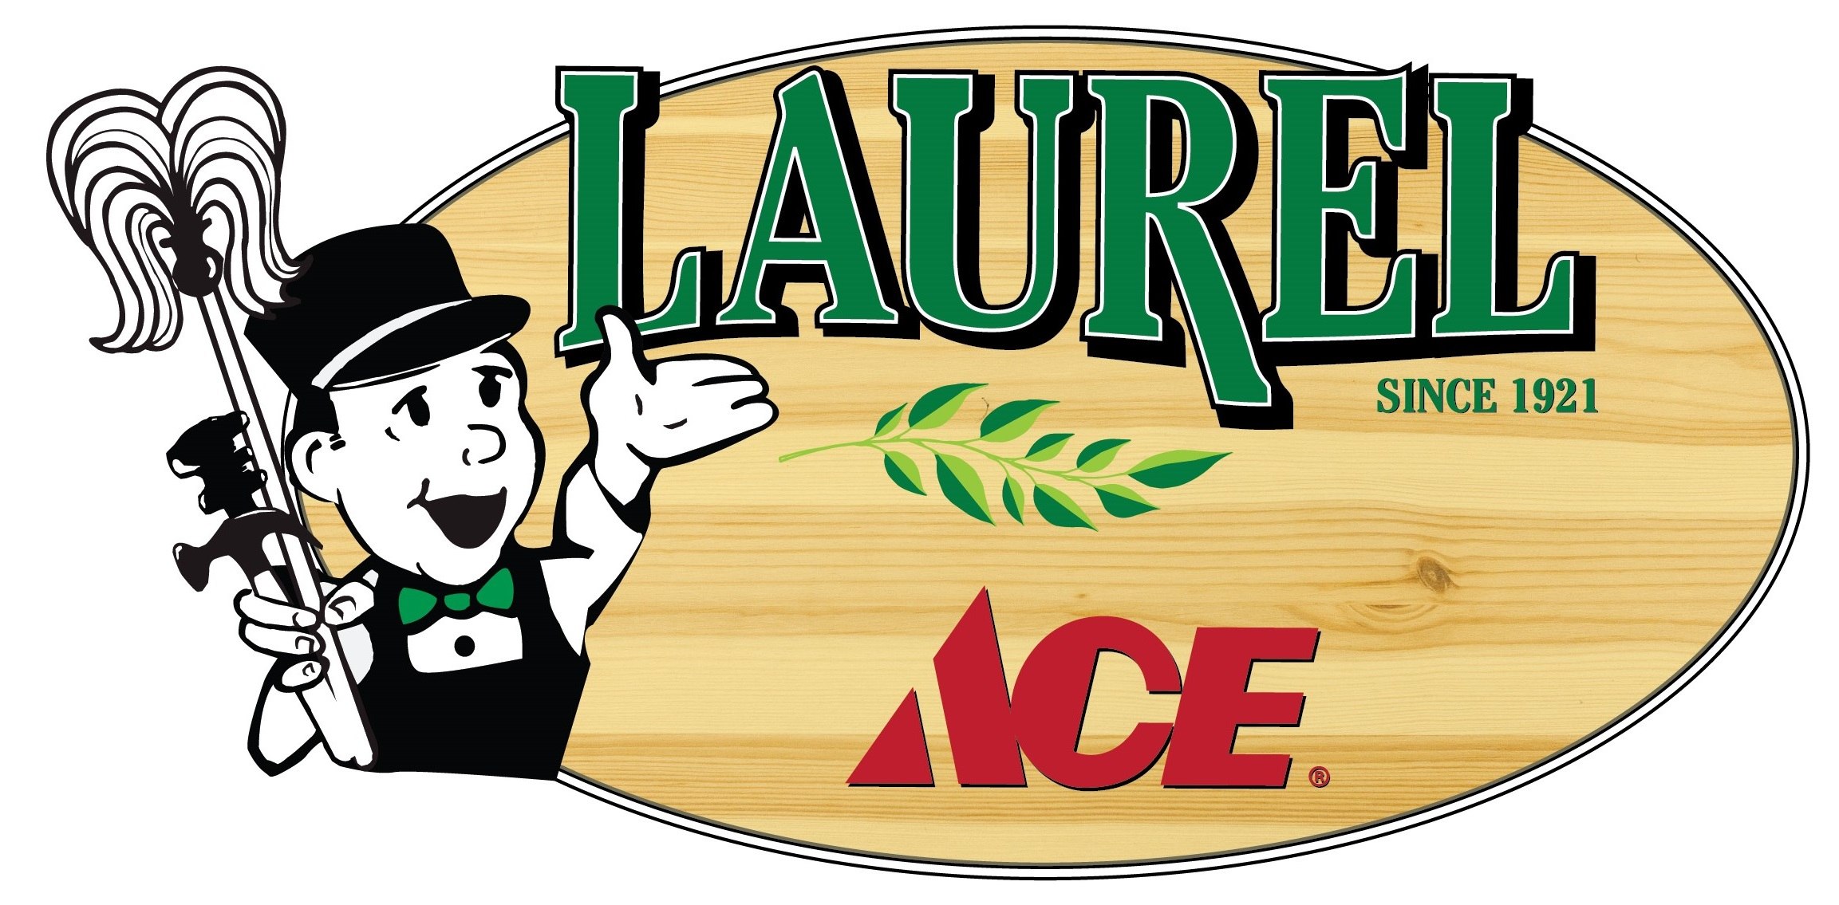
FACT SHEET

Laurel Ace
Your locally owned neighborhood Mom & Pop hardware store since 1921 – Under new management in 2017!

Laurel Ace offers thousands of products at everyday low prices and old-fashioned customer service, making us your one-stop hardware store in Oakland’s Laurel District for nearly 100 years!

MANAGEMENT:
Store Manager: Richard Johnston, rick@laurelace.com
Owners: Jeff Leopold, jeff@laurelace.com
Michelle Leopold (Marketing & Charitable Contributions) michelle@laurelace.com
General Manager and Business Partner: Troy Welch, troy@laurelace.com

STORE LOCATION
In Oakland’s Laurel District:
4024 MacArthur Blvd, Oakland CA 94619
FREE PARKING in lot (Metered parking in front)
STORE HOURS
Monday through Sunday 8:00 AM to 7:00 PM
We hope to extend Weekday Store Hours by June 2017!
Holiday hours may vary
Closed Thanksgiving, Christmas, and New Year’s Day.

contact us:
Phone 510/530-1966
e-mail:shop@laurelace.com
website www.laurelace.com
Find Laurel Ace on Facebook and Twitter
Follow us on Pinterest (as Stan Standard)

History:
Founded in 1921 as Key Route Hardware (when the neighborhood was known as Key Route Heights), this anchor neighborhood hardware store has remained family owned and operated over the past 96 years, with only three families – 1921-1957, 1957-2017, and now with great plans for the next hundred years of service to our neighbors and to the needs of this unique neighborhood. Come by and see what we make fit into 5000 square feet, you have to see it to believe it!

Services:
- Ace Hardware items: thousands in stock & more on special-order
- Ace Rewards, our frequent shopper program – rebates and more!
- Assembly available on most items for a nominal fee
- ATM access ($100.00 cash back)
- B2B Corporate Accounts for all sizes of companies
- Carry-out service available
- Charitable contributions considered (mail requests)
- Charge Accounts available
- Credit cards accepted
- Free email and snail mail newsletter
- Delivery available
- Free Parking in our large parking lot
- Gift Cards available
- Glass Cutting
- Green Products: look for the “helpful earth choices” signs throughout the store
- Key duplicating, including most Chip Keys and Key Fobs
- Made in the USA: look for American-made signs throughout the store
- Military Discount – 10% off year-round with current military ID
- Neonicotinoid-Free Plants and Seeds – to help protect our pollinators!
- No-hassle return policy -- your receipt guarantees that we’ll fix it, exchange it, or return your money within 30 days of purchase, *no questions asked! *
- Online shopping at AceHardware.com, free delivery when you choose “pick up at store”, online inventory allows you to pick up many items the same day!
- Paint color matching
- Pipes cut and rethreaded
- Price Match Guarantee
- Propane tank exchange program
- Recycle your household batteries, CFLs, fluorescent tubes, and American Flags here
- Rug Doctor carpet cleaning rentals
- Screen Repairs and rescreening
- Senior Discount Day - Monday 55+ receive 10% off
- Sharpening service for tools and knives
- Special orders always welcome, including over 250,000 ACE hardware items shipped here in a few days at no extra charge
- Watch Batteries

Updated 5/15/17

Contact:
Michelle Leopold, Owner/Marketing & Charitable Contributions
415/302-4055 cell
marketing@laurelace.com

