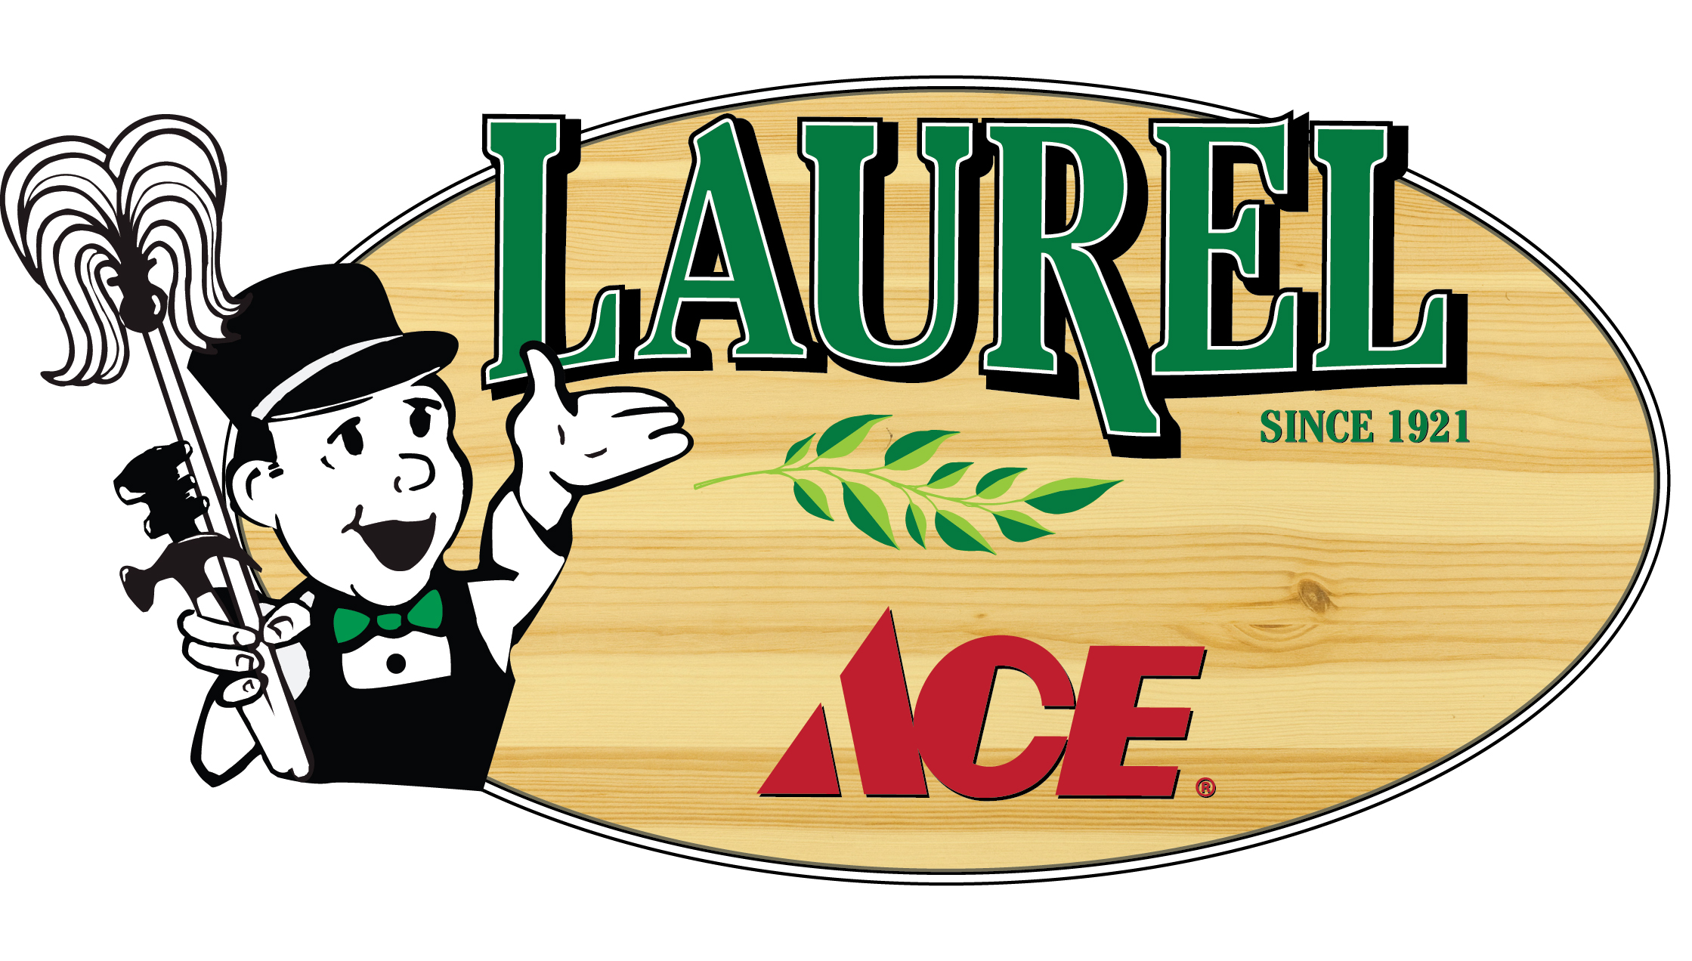

Contact: Michelle Leopold
Laurel Ace
415/302-4055 cell
michelle@laurelace.com

96-Year-Old Laurel Ace Hardware “Under New Management”

New Owners to refresh The Laurel’s anchor neighborhood Hardware Store

Oakland, California (April 27, 2017) – The Laurel District’s 1921 hardware store changed hands on April 26, 2017 and already has begun implementing plans for an even better shopping experience at this 96-year anchor in The Laurel.
Laurel Ace, located at 4024 MacArthur Blvd. in Oakland, now offers even more helpful customer service to Laurel neighbors after the seasoned team has been retrained and return policy has been revamped. The store already resumed longer 8am-6pm daily hours, with plans to open 7-7 weekdays as soon as additional staff are trained. With the addition of a third register, the often-seen line at the front is moving faster already, and a fourth register will be added later in the year. The store has already added new categories to the store’s home improvement mix, including neonic-free annuals, perennials, herbs, vegetables, and succulents, Warriors items, Weber Grills and Big Green Egg cookers, and Sodastream machines, flavors, and cartridge exchanges. The new management will continue to listen to area homeowners, DIYers and local contractors to hear what is missing, and will incorporate these changes as they undergo a complete renovation starting in July, to occur at night without disrupting store hours. In addition, the on-staff “helpful hardware folks” will continue to offer one-on-one expert advice and assistance, a hallmark of the new management’s other 2 Ace stores.
“When we heard Jenny and David Vahlstrom were looking to retire, we explored the Laurel Ace store and neighborhood, and knew we could not only continue the great business that’s been part of The Laurel since 1921, but to bring missing items to the neighborhood hardware store shopping experience” shared Michelle and Jeff Leopold, the mom & pop behind the new locally-owned and operated hardware store. “We look forward to adding a complete housewares section, bringing in seasonal decorations and accessories including holiday lights, solar lighting, and expanding everyday offerings throughout the store, with a focus on unique products that improve one’s shopping experience at a “mom & pop” hardware store.”
This is the third Ace store for Jeff and Michelle Leopold, owners of the landmark 1939 variety store Standard 5&10 Ace in San Francisco’s Laurel Village Shopping Center, and owners of 2011’s new Marin Ace in San Rafael, already a winner of Ace Hardware’s distinguished Pinnacle award, spotlighting the top 5% of all Ace stores in the country. With business partner/General Manager Troy Welch on the team, the ambitious plans for Laurel Ace improvements will have no problem coming to life, as Troy comes from a proven background
-cont’d-
cont’d -
successfully improving existing Ace stores throughout the West Coast. “We’re extremely familiar with the renovation process, and although we can’t promise a dust-free experience, we are certain that the improvements we will make will bring Laurel Ace to 21st Century standards – to last well into their next 100 years.” The aisles at the store will be moved horizontally from their current vertical layout, customer service areas will be more customer-friendly and accessible – and a fourth register will be added, in addition to cosmetic improvements throughout the store. “We know that our customers suffered while the store was closed during the management transition, and we will ensure that our doors remain open regular business hours throughout the entire renovation process,” added Troy. Long-term plans for Laurel Ace include moving key showcase departments to the second level of the store and expanding other strategic departments throughout the store, an ambitious change earmarked for 2018.
“Laurel Ace is committed to providing a wide variety of products for home improvement solutions, helpful advice and resources to residents and local business contractors,” shared Richard “Rick” Johnston, Manager of Laurel Ace and strong customer service advocate. “We are grateful that all eight members of the store’s customer service team stayed on during the transition, and the new team members are quickly catching on to the store’s helpful attitude and inspired changes. Employee morale is strong, and customers are commenting on the positive transition in this key neighborhood business.”
“We’re excited to be part of the community,” shared Michelle, who does the marketing and charitable contributions for the store, “and already have begun to show our participation in The Laurel through business and philanthropic efforts.” Laurel Ace has already launched a website, LaurelAce.com, Social Media conversations on Facebook and Twitter, and will be a sponsor of the Laurel Fair. Business accounts had a seamless transition to the new owners, and local non-profits will soon benefit from this supportive, philanthropic community leader. A Grand Reopening Celebration is planned for the Fall after the renovation is complete.
“This hardware store has a wonderful history in the area, - and unheard of free parking” added store owner Jeff, “and we look forward to continuing to make a positive impact in The Laurel for many years to come.”
Founded in 1921 as Key Route Hardware (when the neighborhood was known as Key Route Heights), Laurel Ace has remained family owned and operated over the past 96 years, in only two locations and three families – 1921-1957, 1957-2017, and now the third being Jeff & Michelle and their partner Troy, with great plans for the next hundred years of service to neighbors and to the neighborhood, right on MacArthur Blvd. Laurel Ace is part of the Ace Hardware cooperative, with 5,000 individually owned and operated stores around the globe. Ace Hardware prides themselves on their unsurpassed tradition of being “Ace Helpful” – and the entire Laurel Ace team will strive to uphold Ace’s pledge: “helping you is the most important thing we have to do every day.”
# # #

